Brian Zhang
ESE 124
HW 1
2/20/14

Designed code:

- | 0 | 1 | 2 | 3 | 4 | 5 | 6 | 7 | 8 | 9 | 10 | 11 | 12 | 13 | 14 | 15 | 16 | 17 | 18 | 19 | 20 | 21 | 22 | 23 | 24 | 25 | 26 | 27 | 28 | 29 | 30 | 31 | 32 | 33 | 34 | 35 | 36 | 37 | 38 | 39 | 40 | 41 | 42 | 43 | 44 | 45 | 46
0 |  | Z | Z | Z | Z | Z | Z | Z | Z | Z | Z | Z | Z |  |  | Z | Z |  |  |  |  |  |  |  | Z | Z |  |  |  |  |  |  |  |  |  |  |  | Z
1 | Z | Z | Z | Z | Z | Z | Z | Z | Z | Z | Z | Z |  |  |  | Z | Z |  |  |  |  |  |  |  | Z | Z |  |  |  |  |  |  |  |  |  |  | Z | Z | Z
2 |  |  |  |  |  |  |  |  |  | Z | Z |  |  |  |  | Z | Z |  |  |  |  |  |  |  | Z | Z |  |  |  |  |  |  |  |  |  | Z | Z | Z | Z | Z
3 |  |  |  |  |  |  |  | Z | Z |  |  |  |  |  |  | Z | Z |  |  |  |  |  |  |  | Z | Z |  |  |  |  |  |  |  |  | Z | Z |  |  |  | Z | Z
4 |  |  |  |  |  |  | Z | Z |  |  |  |  |  |  |  | Z | Z | Z | Z | Z | Z | Z | Z | Z | Z | Z |  |  |  |  |  |  |  | Z | Z |  |  |  |  |  | Z | Z
5 |  |  |  |  |  | Z | Z |  |  |  |  |  |  |  |  | Z | Z | Z | Z | Z | Z | Z | Z | Z | Z | Z |  |  |  |  |  |  | Z | Z | Z | Z | Z | Z | Z | Z | Z | Z | Z
6 |  |  |  |  | Z | Z |  |  |  |  |  |  |  |  |  | Z | Z |  |  |  |  |  |  |  | Z | Z |  |  |  |  |  | Z | Z | Z | Z | Z | Z | Z | Z | Z | Z | Z | Z | Z
7 |  |  |  | Z | Z |  |  |  |  |  |  |  |  |  |  | Z | Z |  |  |  |  |  |  |  | Z | Z |  |  |  |  | Z | Z |  |  |  |  |  |  |  |  |  |  |  | Z | Z
8 |  | Z | Z | Z | Z | Z | Z | Z | Z | Z | Z | Z | Z |  |  | Z | Z |  |  |  |  |  |  |  | Z | Z |  |  |  | Z | Z |  |  |  |  |  |  |  |  |  |  |  |  |  | Z | Z
9 | Z | Z | Z | Z | Z | Z | Z | Z | Z | Z | Z | Z |  |  |  | Z | Z |  |  |  |  |  |  |  | Z | Z |  |  | Z | Z |  |  |  |  |  |  |  |  |  |  |  |  |  |  |  | Z | Z

Code:
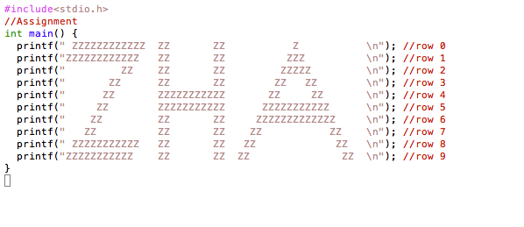
Terminal Output:
